Hosting a web app using Kubernetes:-
Installing Minikube and performing Hands-on on Docker Desktop :--
For running Minikube on your local system, you need Docker desktop on your system.
I have already installed Docker Desktop on my machine, you can download it from below link:-
https://www.docker.com/products/docker-desktop/



After installation, we can see our Docker Desktop is up and running.

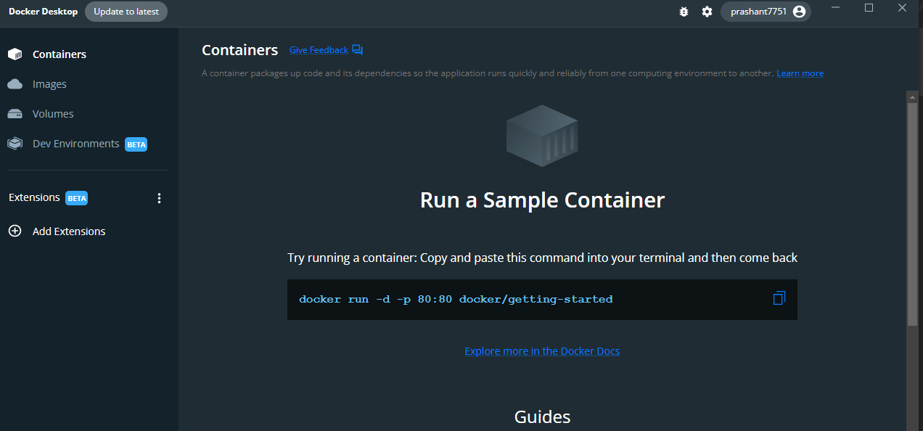

Now we will work on installing Minikube on our machine:-
Follow below link
https://minikube.sigs.k8s.io/docs/start/

To install the latest minikube stable release on x86-64 Windows using .exe download:
- Download and run the installer for the latest release.
Or if using PowerShell, use this command:
- New-Item -Path 'c:\' -Name 'minikube' -ItemType Directory -Force
- Invoke-WebRequest -OutFile 'c:\minikube\minikube.exe' -Uri 'https://github.com/kubernetes/minikube/releases/latest/download/minikube-windows-amd64.exe' -UseBasicParsing
Copy
- Add the minikube.exe binary to your PATH.
Make sure to run PowerShell as Administrator.
- $oldPath = [Environment]::GetEnvironmentVariable('Path', [EnvironmentVariableTarget]::Machine)
- if ($oldPath.Split(';') -inotcontains 'C:\minikube'){ `
- [Environment]::SetEnvironmentVariable('Path', $('{0};C:\minikube' -f $oldPath), [EnvironmentVariableTarget]::Machine) `
}

You should have administrator level privilege then only you can configure these paths.
Now we will start with Minikube by launching PowerShell on our machine.
Make sure that Kubectl is installed on your system, for that too, you need admin level privileges.
https://kubernetes.io/docs/tasks/tools/install-kubectl-windows/
curl.exe -LO "https://dl.k8s.io/release/v1.25.0/bin/windows/amd64/kubectl.exe"
you can launch this command through Git bash or PowerShell.

Download the kubectl checksum file:
curl.exe -LO "https://dl.k8s.io/v1.25.0/bin/windows/amd64/kubectl.exe.sha256"

- Validate the kubectl binary against the checksum file:
  - Using Command Prompt to manually compare CertUtil's output to the checksum file downloaded:
  - CertUtil -hashfile kubectl.exe SHA256
  - type kubectl.exe.sha256
  - Using PowerShell to automate the verification using the -eq operator to get a True or False result:
  - $($(CertUtil -hashfile .\kubectl.exe SHA256)[1] -replace " ", "") -eq $(type .\kubectl.exe.sha256)
- Append or prepend the kubectl binary folder to your PATH environment variable.

Now Kubectl is installed on our system.
We will check the version of Kubectl on our system.
By launching command
kubectl version --client
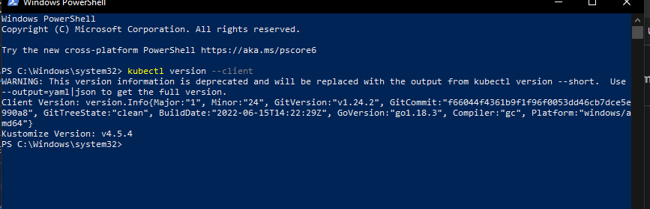
Minikube:-
Follow this link for better understanding
https://minikube.sigs.k8s.io/docs/start/
Simply type minikube start it will start minikube.
If you face any difficulties then go to below link for possible troubleshoots :-

https://minikube.sigs.k8s.io/docs/drivers/

In my case it’s docker on windows, I can go for command
minikube start --driver=docker
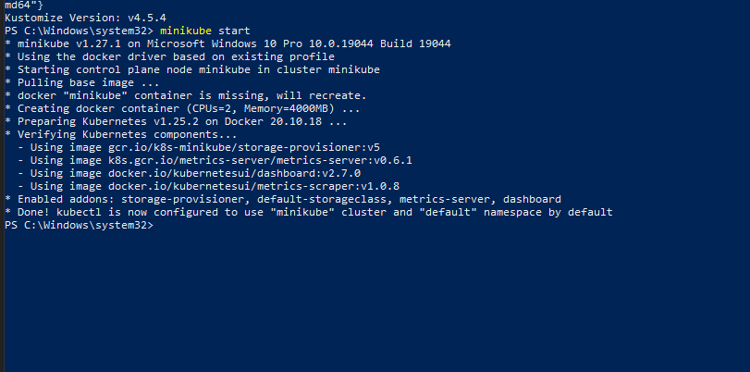
Now we will check status of minikube :-
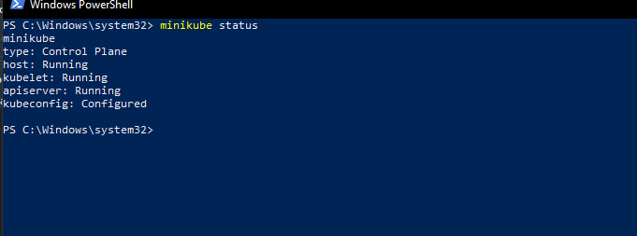

It’s running, we can cross check it in looking at our docker desktop

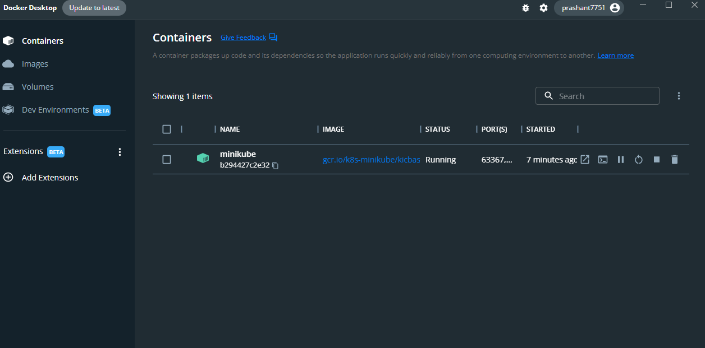

We need to host already developed web app on Kubernetes, we are using Minikube as a platform which will help us in achieving our requirement.
Here app development team will send us app in .war format, then we will make one directory and keep our .war file there, we have created directory as
C:\Users\Prashant.Abhishek\Downloads\21-11-22backend
Then we will work on Docker file and Docker image creation.
We can build docker file by going into the path where we have kept our .war file.
After that we can issue below command to make docker file
nano Dockerfile
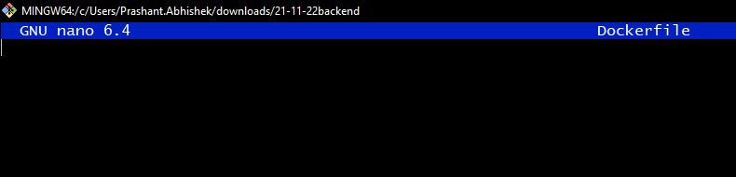
This window will get open, here we have to put our docker file script

Script will be
FROM tomcat:9.0.65-jdk17-temurin-jammy
COPY vrsu.war /usr/local/tomcat/webapps
CMD ["catalina.sh", "run"]
We will put this script for the Dockerfile creation
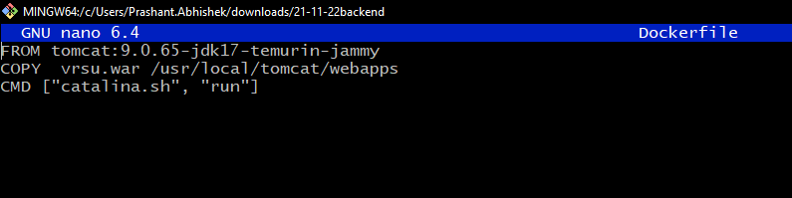
Cntl+X and Shit+Y to save and close the terminal.
Now we will work on building image
For that we have to issue command
docker build -t vrsu
Our image is built now.
We can run the image by using command
docker run -itd -p 8089:8080 --name vrsu vrsu
Once that image is there, we can see in docker images as well
By issuing command
docker ps -a
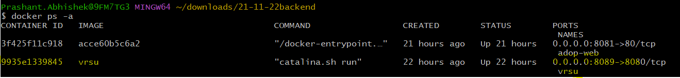
or
docker images
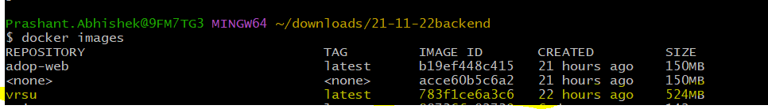

Once our Docker image is built, we can see that running in our Docker desktop app.

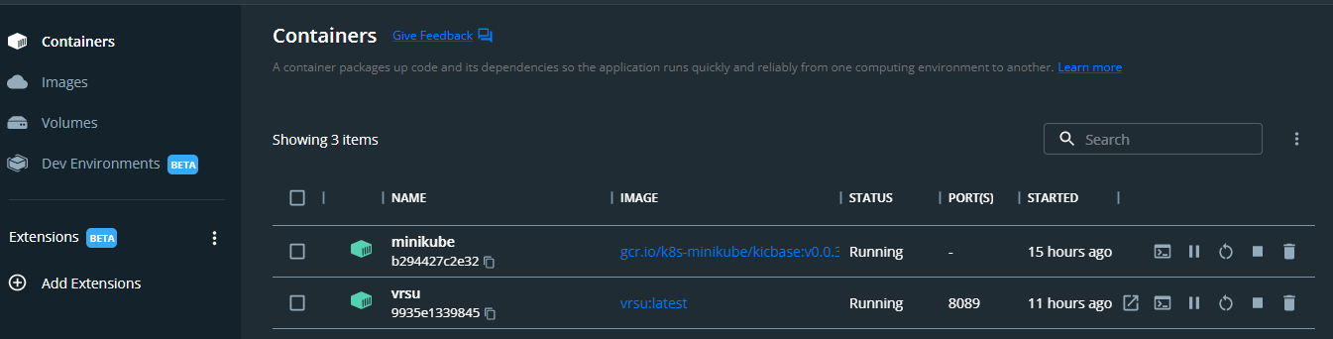

So, our image name is vrsu:latest and it’s in running state.

We can check that on local host as well
By issuing command
http://localhost:8089/vrsu/api/subscriber/welcome

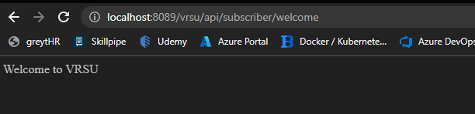

Now we have to work on creating Manifest for hosting the app.
Testweb.yaml script will be as below,
We have to write two scripts, one is for Service and another for Deployment.
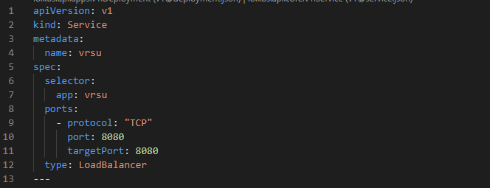
We can write multiple yaml scripts in the same file, --- is used to separate the content.
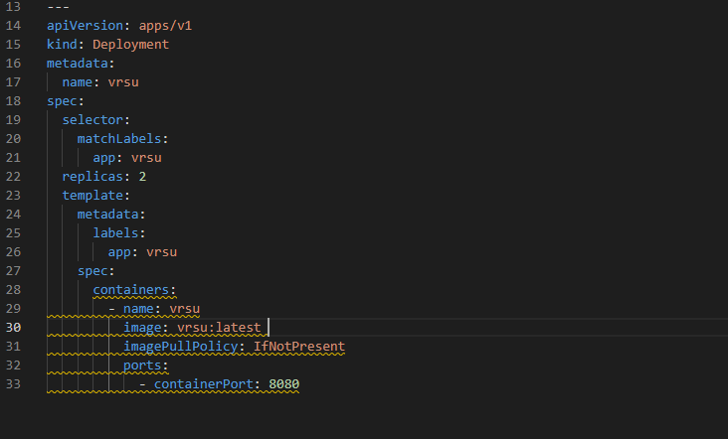

Here we have used image is vrsu:latest which is our image built by using docker.

Now there are certain sets of commands to follow by which we can deploy our app on Minikube.

Many times, Minikube may not be able to fetch the image directly from Docker desktop, in that case we have to push that image manually, for that we can use below command
minikube image load vrsu:latest
Then our image will be loaded there in minikube.
After that we have to go to the folder where we have kept our .yaml file
We have kept my file name as Testweb.yaml
And it’s in downloads directory.
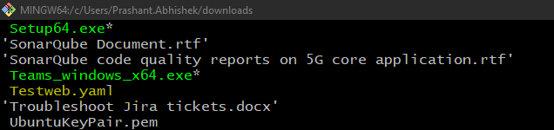
For deploying our pods we have to issue command
kubectl apply -f Testweb.yaml
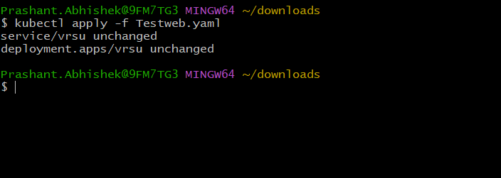
As I have already applied this command, so it’s coming as unchanged or else, it would have came as
service/vrsu created
deployment.apps created

Now we can check the status of our pods by launching command
kubectl get pods
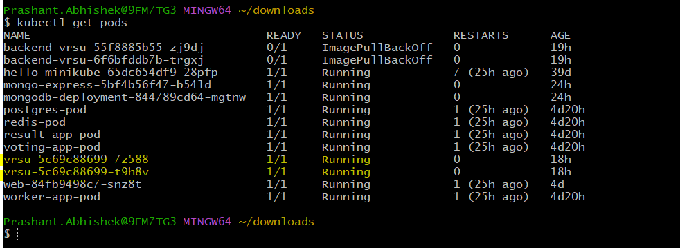
We can see both pods for our service and deployment is running and in ready state.
Now we can see our services by launching command
kubectl get service
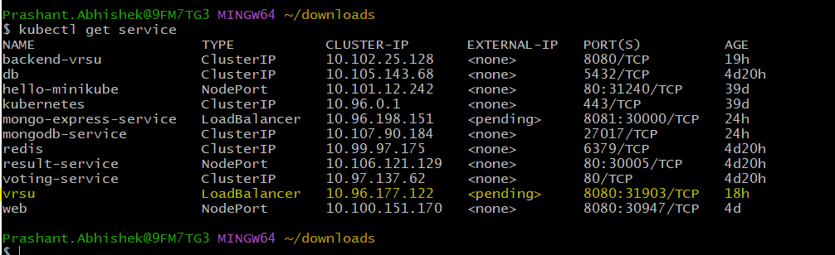

As we can see our app is running and external service is LoadBalancer, and the external IP is in pending state, we can make that available by running command

minikube service vrsu
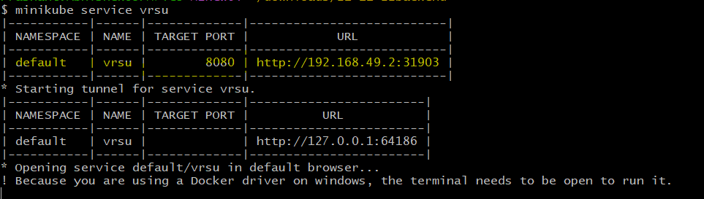

So, our LoadBalancer have a specific address from which we can get our application.
As soon as you launch that command below terminal will open
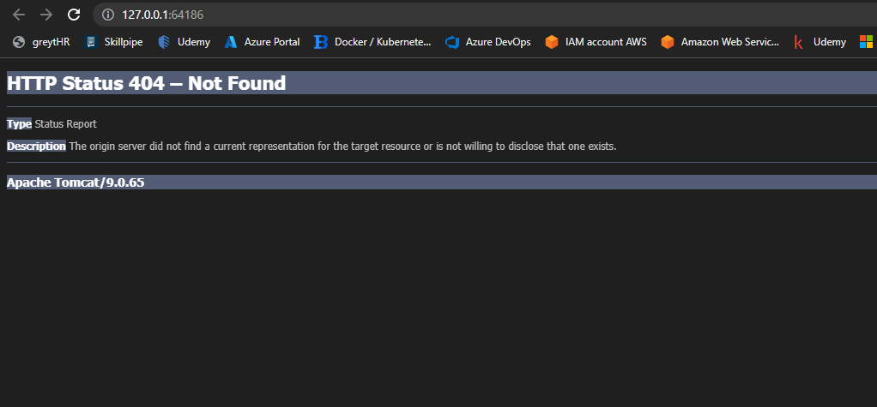
Here we are getting HTTP 404, error, because we haven’t specified the path for the app, now we will define that as
http://127.0.0.1:64186/vrsu/api/subscriber/welcome
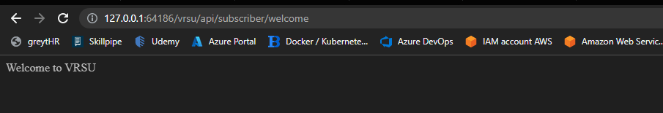
Our application is successfully hosted on Minikube.
*IP address will change as soon as you close your terminal*

